Experiment Number: 1

Problem Statement:

NAME: Manomay Jamble ROLLNO: 49

CLASS: TY(AIDS-A) BATCH: 3

DATE OF PERFORMANCE: 01-09-22

___________________________________________________________________________

1. **Date:**

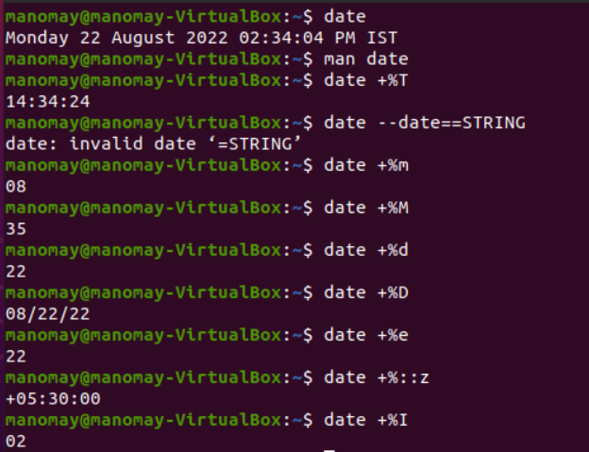

1. **Cal:**

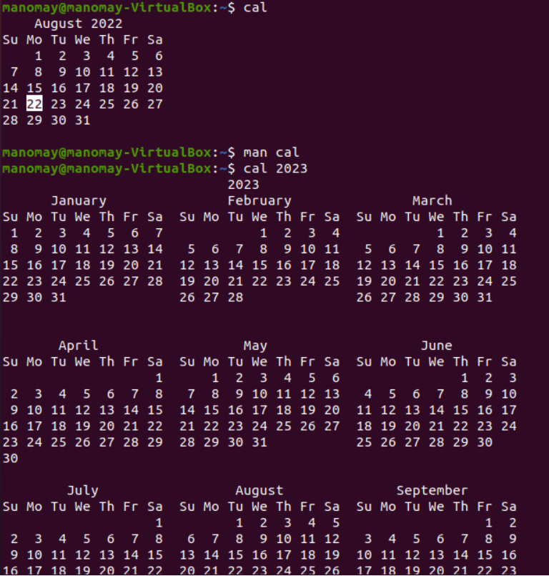

1. **Who:**

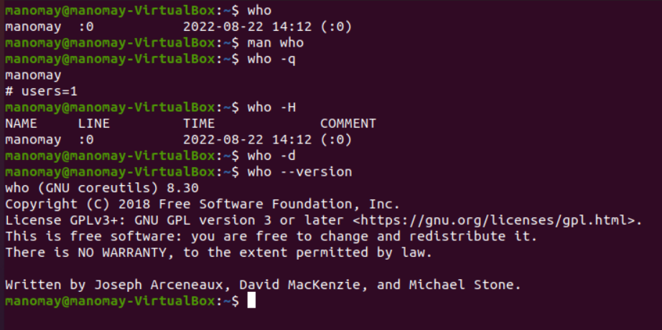

1. **Whoami:**

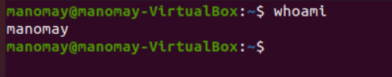

1. **Echo:**

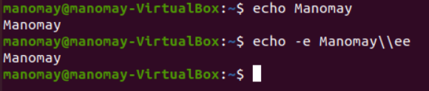

1. **bc:**

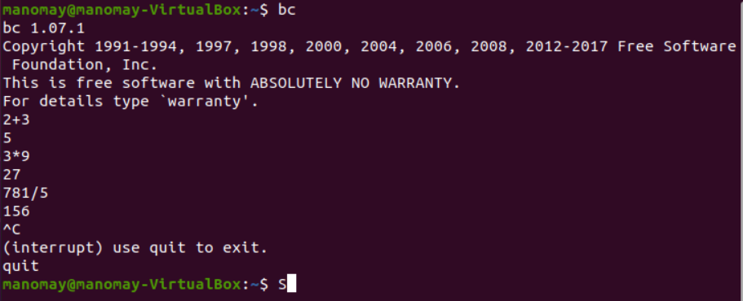

1. **man:**

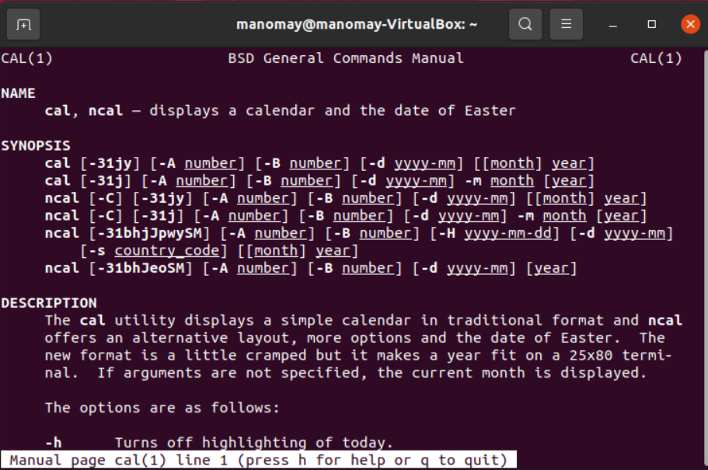

1. **passwd:**

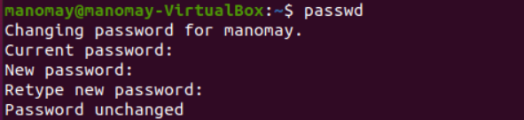

1. **cp:**

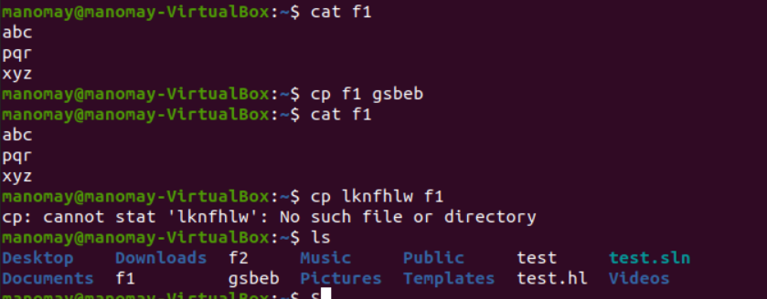

1. **mv:**

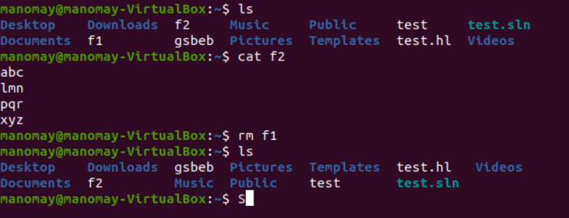

1. **rm:**



1. **mkdir:**

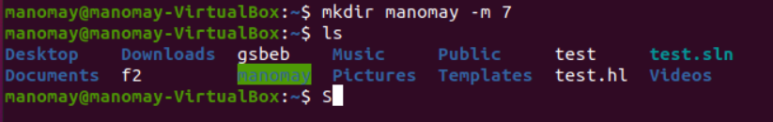

1. **rmdir:**

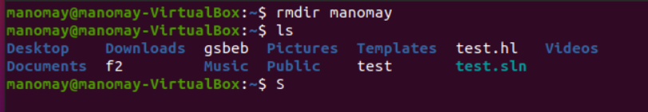

1. **cd:**

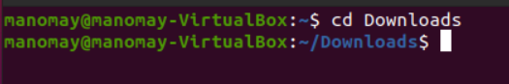

1. **pwd:**

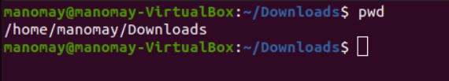

1. **cat:**

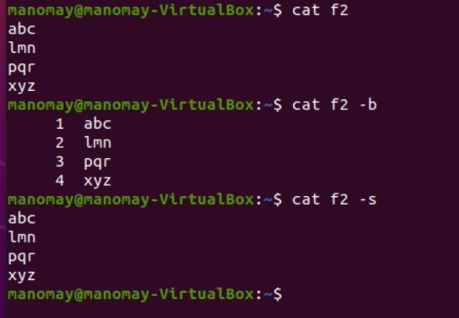

1. **more:**

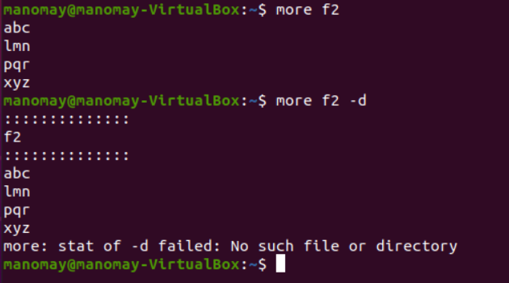

1. **file:**

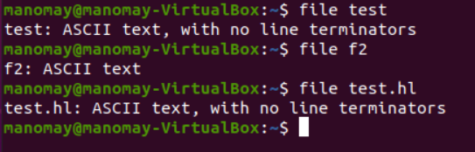

1. **wc:**

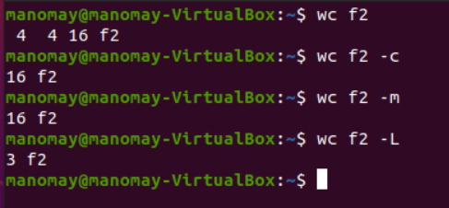

1. **cmp:**

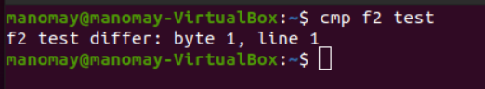

1. **comm:**

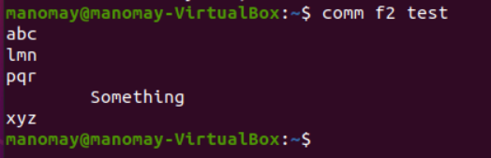

1. **diff:**

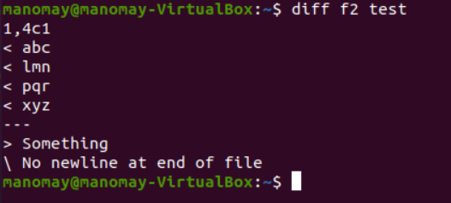

1. **gzip:**

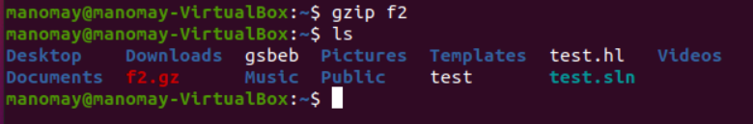

1. **gunzip:**

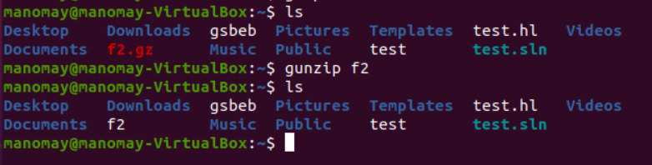

1. **ls:**

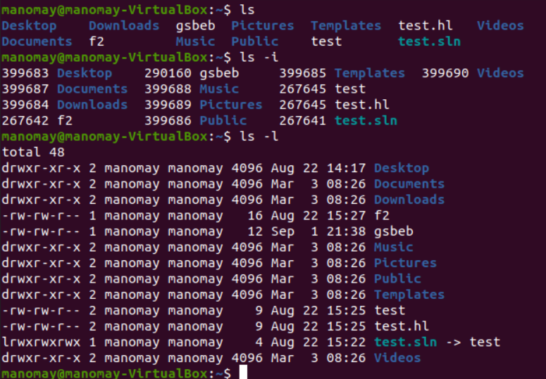

1. **ln:**

